(Approx. 468 words)

Neverputt
By Cal Esneault, Former President of CCCC; leader of many Open Source Workshops & SIGs
January 2015 issue, CCCC Computer News
Newsletter (at) clickers.org
www.clickers.org

Neverputt is a multi-player miniature golf computer game available as a free download for Linux, Windows, and MAC OS. The underlying physics simulator and OpenGL renderer were originally developed for Neverball, a classic motion-sensing game where a ball is manipulated to strike targets and increase your score. Both of these games support mouse, keyboard, game pad, and joystick input (they were originally created about a decade ago). Neverputt allows selection of 7 different courses of varying difficulty. It is a challenging game combining both skill and strategy and is suitable for all ages.

I installed Version 1.5.4 from the Ubuntu repository for my Linux Mint system. Screenshots below show the layout for one of the "easy" holes. A triangular guide behind the ball allows you to aim the direction and determine stroke intensity based on the length of the guide. The three-dimensional view changes as you aim to give you proper perspective. Swing too easy and the ball will not reach the target. Swing too hard and the ball will hit the flag and bounce to the side or it will bounce over the side rail and result in a one-stroke penalty. Based on layout configuration, "par" values range from 2 to 5 strokes. An updated scorecard is provided after each hole. For multi-players, participant shots rotate in turn.
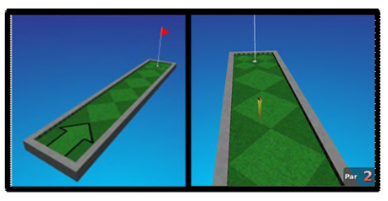
As you progress through a course, different challenges appear. For example, below (left) forces you up an incline and then down a ramp. A "hole" is in the middle of the turn (fall into it and you get a penalty stroke. Other obstacles include moving walls, "dips" and "hills" in your path, ramps with no borders that let the ball fall off the course, etc. You can be aggressive and try to conquer the problem quickly to reduce stokes or slowly "nudge" into a better position with more, but controlled, intermediate shots. Some of the courses include strange ramps and multi-levels as shown below (right). A few holes are frustratingly difficult, but after numerous shots the game will mercifully let you pass onto the next hole.
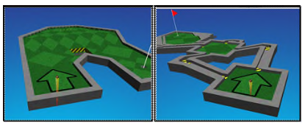
The game engine follows realistics physics. For example, a ball will roll up and down a depression until it comes to rest after a realistic time, energy will dissipate when you hit a border wall, and the ball will curve if rolled at an angle on a hill.

Neverputt is distributed as part of the Neverball network (go to neverball.org). Also, Neverputt has been released to the open-source community at large. The web site lists the names of the many contributors, and it also lists the specific areas in which these developers and artists have helped.



